Lab 7
Tên: Trần Đức
MSSV: 1150080131

Thực hành 1: Hiển thị dữ liệu trên control DataGridView
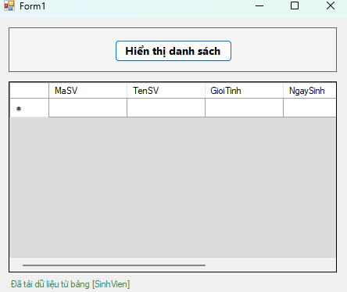

Form1.cs
using System;
using System.Data;
using System.Data.SqlClient;
using System.Windows.Forms;

namespace _1150080131_TranDuc_Lab7
{
public partial class Form1 : Form
{
// ⚙️ Kết nối – bạn giữ nguyên hoặc chỉnh lại nếu cần
private const string CONN_STR =
@"Data Source=LAPTOP-LQGGA8E3\MSSQLSERVER2;Initial Catalog=QLSV;Integrated Security=True;Persist Security Info=False;Encrypt=True;TrustServerCertificate=True";

// 🔁 Tên bảng cần hiển thị
private const string TABLE_NAME = "SinhVien"; // đổi thành bảng bạn có, ví dụ: NhaXuatBan, Lop, …

public Form1()
{
InitializeComponent();
}

private void btnHienThi_Click(object sender, EventArgs e)
{
try
{
using (var con = new SqlConnection(CONN_STR))
{
con.Open();

// Lấy tất cả cột của bảng cần hiển thị
string sql = $"SELECT * FROM [{TABLE_NAME}]";

using (var da = new SqlDataAdapter(sql, con))
{
var ds = new DataSet();
da.Fill(ds, TABLE_NAME);
dgvDanhSach.DataSource = ds.Tables[TABLE_NAME];
}
}
lblStatus.Text = $"Đã tải dữ liệu từ bảng [{TABLE_NAME}]";
}
catch (Exception ex)
{
lblStatus.Text = "Lỗi tải dữ liệu!";
MessageBox.Show(ex.Message, "Lỗi", MessageBoxButtons.OK, MessageBoxIcon.Error);
}
}
}
}

Form1.Desginer.cs
namespace _1150080131_TranDuc_Lab7
{
partial class Form1
{
private System.ComponentModel.IContainer components = null;
private System.Windows.Forms.Button btnHienThi;
private System.Windows.Forms.DataGridView dgvDanhSach;
private System.Windows.Forms.Panel panelTop;
private System.Windows.Forms.Label lblStatus;

protected override void Dispose(bool disposing)
{
if (disposing && (components != null))
components.Dispose();
base.Dispose(disposing);
}

private void InitializeComponent()
{
this.panelTop = new System.Windows.Forms.Panel();
this.btnHienThi = new System.Windows.Forms.Button();
this.dgvDanhSach = new System.Windows.Forms.DataGridView();
this.lblStatus = new System.Windows.Forms.Label();
this.panelTop.SuspendLayout();
((System.ComponentModel.ISupportInitialize)(this.dgvDanhSach)).BeginInit();
this.SuspendLayout();
//
// panelTop
//
this.panelTop.Anchor = ((System.Windows.Forms.AnchorStyles)(((System.Windows.Forms.AnchorStyles.Top | System.Windows.Forms.AnchorStyles.Left)
| System.Windows.Forms.AnchorStyles.Right)));
this.panelTop.BackColor = System.Drawing.Color.WhiteSmoke;
this.panelTop.BorderStyle = System.Windows.Forms.BorderStyle.FixedSingle;
this.panelTop.Controls.Add(this.btnHienThi);
this.panelTop.Location = new System.Drawing.Point(20, 15);
this.panelTop.Name = "panelTop";
this.panelTop.Size = new System.Drawing.Size(560, 70);
this.panelTop.TabIndex = 0;
//
// btnHienThi
//
this.btnHienThi.Anchor = System.Windows.Forms.AnchorStyles.Top;
this.btnHienThi.Font = new System.Drawing.Font("Segoe UI", 10F, System.Drawing.FontStyle.Bold);
this.btnHienThi.Location = new System.Drawing.Point(180, 18);
this.btnHienThi.Name = "btnHienThi";
this.btnHienThi.Size = new System.Drawing.Size(200, 35);
this.btnHienThi.TabIndex = 0;
this.btnHienThi.Text = "Hiển thị danh sách";
this.btnHienThi.UseVisualStyleBackColor = true;
this.btnHienThi.Click += new System.EventHandler(this.btnHienThi_Click);
//
// dgvDanhSach
//
this.dgvDanhSach.Anchor = ((System.Windows.Forms.AnchorStyles)((((System.Windows.Forms.AnchorStyles.Top | System.Windows.Forms.AnchorStyles.Bottom)
| System.Windows.Forms.AnchorStyles.Left)
| System.Windows.Forms.AnchorStyles.Right)));
this.dgvDanhSach.BackgroundColor = System.Drawing.Color.Gainsboro;
this.dgvDanhSach.BorderStyle = System.Windows.Forms.BorderStyle.FixedSingle;
this.dgvDanhSach.ColumnHeadersHeightSizeMode = System.Windows.Forms.DataGridViewColumnHeadersHeightSizeMode.AutoSize;
this.dgvDanhSach.Location = new System.Drawing.Point(20, 100);
this.dgvDanhSach.Name = "dgvDanhSach";
this.dgvDanhSach.RowHeadersWidth = 51;
this.dgvDanhSach.RowTemplate.Height = 24;
this.dgvDanhSach.Size = new System.Drawing.Size(560, 300);
this.dgvDanhSach.TabIndex = 1;
//
// lblStatus
//
this.lblStatus.Anchor = ((System.Windows.Forms.AnchorStyles)((System.Windows.Forms.AnchorStyles.Bottom | System.Windows.Forms.AnchorStyles.Left)));
this.lblStatus.AutoSize = true;
this.lblStatus.ForeColor = System.Drawing.Color.SeaGreen;
this.lblStatus.Location = new System.Drawing.Point(20, 410);
this.lblStatus.Name = "lblStatus";
this.lblStatus.Size = new System.Drawing.Size(0, 16);
this.lblStatus.TabIndex = 2;
//
// Form1
//
this.AutoScaleDimensions = new System.Drawing.SizeF(8F, 16F);
this.AutoScaleMode = System.Windows.Forms.AutoScaleMode.Font;
this.ClientSize = new System.Drawing.Size(600, 440);
this.Controls.Add(this.lblStatus);
this.Controls.Add(this.dgvDanhSach);
this.Controls.Add(this.panelTop);
this.MinimumSize = new System.Drawing.Size(500, 350);
this.Name = "Form1";
this.StartPosition = System.Windows.Forms.FormStartPosition.CenterScreen;
this.Text = "Form1";
this.panelTop.ResumeLayout(false);
((System.ComponentModel.ISupportInitialize)(this.dgvDanhSach)).EndInit();
this.ResumeLayout(false);
this.PerformLayout();
}
}
}

Thực hành 2: Thêm dữ liệu cho bảng Nhà xuất bản
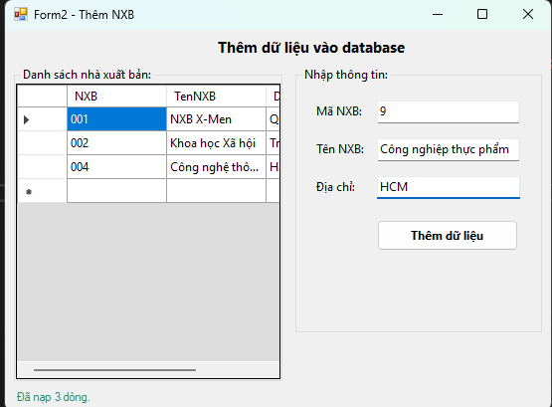

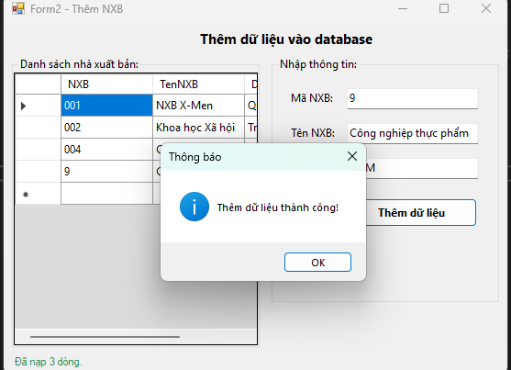

Form2.cs
using System;
using System.Data;
using System.Data.SqlClient;
using System.Windows.Forms;

namespace _1150080131_TranDuc_Lab7
{
public partial class Form2 : Form
{
// ====== Cấu hình nhanh ======
private const string CONN_STR =
@"Data Source=LAPTOP-LQGGA8E3\MSSQLSERVER2;Initial Catalog=QLSV;Integrated Security=True;Persist Security Info=False;Encrypt=True;TrustServerCertificate=True";
private const string TABLE = "NhaXuatBan";
private const string COL_MA = "NXB";
private const string COL_TEN = "TenNXB";
private const string COL_DC = "DiaChi";
// =============================

private SqlConnection sqlCon;
private SqlDataAdapter adapter;
private DataSet ds;

public Form2()
{
InitializeComponent();
}

// Mở kết nối
private void MoKetNoi()
{
if (sqlCon == null)
sqlCon = new SqlConnection(CONN_STR);
if (sqlCon.State == ConnectionState.Closed)
sqlCon.Open();
}

// Đóng kết nối
private void DongKetNoi()
{
if (sqlCon != null && sqlCon.State == ConnectionState.Open)
sqlCon.Close();
}

// Xóa dữ liệu trên form
private void XoaDuLieuForm()
{
txtMaNXB.Text = "";
txtTenNXB.Text = "";
txtDiaChi.Text = "";
txtMaNXB.Focus();
}

// Hiển thị dữ liệu lên DataGridView
private void HienThiDuLieu()
{
try
{
MoKetNoi();

string query = $"SELECT * FROM [{TABLE}]";
adapter = new SqlDataAdapter(query, sqlCon);

// Tự phát sinh lệnh Insert/Update/Delete
SqlCommandBuilder builder = new SqlCommandBuilder(adapter);

ds = new DataSet();
adapter.Fill(ds, TABLE);

dgvDanhSach.DataSource = ds.Tables[TABLE];
lblStatus.Text = $"Đã nạp {ds.Tables[TABLE].Rows.Count} dòng.";
}
catch (Exception ex)
{
MessageBox.Show(ex.Message, "Lỗi tải dữ liệu", MessageBoxButtons.OK, MessageBoxIcon.Error);
}
finally
{
DongKetNoi();
}
}

private void Form2_Load(object sender, EventArgs e)
{
HienThiDuLieu();
XoaDuLieuForm();
}

private bool ValidateInput(out string msg)
{
if (string.IsNullOrWhiteSpace(txtMaNXB.Text))
{
msg = "Vui lòng nhập Mã NXB.";
return false;
}
if (string.IsNullOrWhiteSpace(txtTenNXB.Text))
{
msg = "Vui lòng nhập Tên NXB.";
return false;
}
msg = "";
return true;
}

// Thêm dữ liệu
private void btnThem_Click(object sender, EventArgs e)
{
try
{
if (!ValidateInput(out string msg))
{
MessageBox.Show(msg, "Thiếu dữ liệu", MessageBoxButtons.OK, MessageBoxIcon.Warning);
return;
}

// Tạo dòng mới trong DataSet
DataRow row = ds.Tables[TABLE].NewRow();
row[COL_MA] = txtMaNXB.Text.Trim();
row[COL_TEN] = txtTenNXB.Text.Trim();
row[COL_DC] = txtDiaChi.Text.Trim();

ds.Tables[TABLE].Rows.Add(row);

// Ghi ngược vào DB
MoKetNoi();
int kq = adapter.Update(ds.Tables[TABLE]);

if (kq > 0)
{
MessageBox.Show("Thêm dữ liệu thành công!", "Thông báo", MessageBoxButtons.OK, MessageBoxIcon.Information);
HienThiDuLieu(); // refetch để thấy dữ liệu mới
XoaDuLieuForm();
}
else
{
MessageBox.Show("Thêm dữ liệu không thành công!", "Thông báo", MessageBoxButtons.OK, MessageBoxIcon.Warning);
}
}
catch (SqlException sx) when (sx.Number == 2627 || sx.Number == 2601) // trùng khóa
{
MessageBox.Show("Mã NXB đã tồn tại (trùng khóa).", "Lỗi", MessageBoxButtons.OK, MessageBoxIcon.Error);
}
catch (Exception ex)
{
MessageBox.Show(ex.Message, "Lỗi thêm dữ liệu", MessageBoxButtons.OK, MessageBoxIcon.Error);
}
finally
{
DongKetNoi();
}
}
}
}

Form2.Desginer.cs
namespace _1150080131_TranDuc_Lab7
{
partial class Form2
{
private System.ComponentModel.IContainer components = null;
private System.Windows.Forms.DataGridView dgvDanhSach;
private System.Windows.Forms.GroupBox groupBoxLeft;
private System.Windows.Forms.GroupBox groupBoxRight;
private System.Windows.Forms.Label labelMa;
private System.Windows.Forms.Label labelTen;
private System.Windows.Forms.Label labelDiaChi;
private System.Windows.Forms.TextBox txtMaNXB;
private System.Windows.Forms.TextBox txtTenNXB;
private System.Windows.Forms.TextBox txtDiaChi;
private System.Windows.Forms.Button btnThem;
private System.Windows.Forms.Label lblStatus;
private System.Windows.Forms.Label lblTitle;

protected override void Dispose(bool disposing)
{
if (disposing && (components != null))
components.Dispose();
base.Dispose(disposing);
}

private void InitializeComponent()
{
this.groupBoxLeft = new System.Windows.Forms.GroupBox();
this.dgvDanhSach = new System.Windows.Forms.DataGridView();
this.groupBoxRight = new System.Windows.Forms.GroupBox();
this.labelMa = new System.Windows.Forms.Label();
this.labelTen = new System.Windows.Forms.Label();
this.labelDiaChi = new System.Windows.Forms.Label();
this.txtMaNXB = new System.Windows.Forms.TextBox();
this.txtTenNXB = new System.Windows.Forms.TextBox();
this.txtDiaChi = new System.Windows.Forms.TextBox();
this.btnThem = new System.Windows.Forms.Button();
this.lblStatus = new System.Windows.Forms.Label();
this.lblTitle = new System.Windows.Forms.Label();
this.groupBoxLeft.SuspendLayout();
((System.ComponentModel.ISupportInitialize)(this.dgvDanhSach)).BeginInit();
this.groupBoxRight.SuspendLayout();
this.SuspendLayout();
//
// lblTitle
//
this.lblTitle.Anchor = System.Windows.Forms.AnchorStyles.Top;
this.lblTitle.AutoSize = true;
this.lblTitle.Font = new System.Drawing.Font("Segoe UI", 11F, System.Drawing.FontStyle.Bold);
this.lblTitle.Location = new System.Drawing.Point(280, 9);
this.lblTitle.Name = "lblTitle";
this.lblTitle.Size = new System.Drawing.Size(225, 25);
this.lblTitle.TabIndex = 99;
this.lblTitle.Text = "Thêm dữ liệu vào database";
//
// groupBoxLeft
//
this.groupBoxLeft.Anchor = ((System.Windows.Forms.AnchorStyles)(((System.Windows.Forms.AnchorStyles.Top | System.Windows.Forms.AnchorStyles.Bottom)
| System.Windows.Forms.AnchorStyles.Left)));
this.groupBoxLeft.Controls.Add(this.dgvDanhSach);
this.groupBoxLeft.Font = new System.Drawing.Font("Segoe UI", 9F);
this.groupBoxLeft.Location = new System.Drawing.Point(12, 45);
this.groupBoxLeft.Name = "groupBoxLeft";
this.groupBoxLeft.Size = new System.Drawing.Size(360, 390);
this.groupBoxLeft.TabIndex = 0;
this.groupBoxLeft.TabStop = false;
this.groupBoxLeft.Text = "Danh sách nhà xuất bản:";
//
// dgvDanhSach
//
this.dgvDanhSach.BackgroundColor = System.Drawing.Color.Gainsboro;
this.dgvDanhSach.BorderStyle = System.Windows.Forms.BorderStyle.FixedSingle;
this.dgvDanhSach.ColumnHeadersHeightSizeMode = System.Windows.Forms.DataGridViewColumnHeadersHeightSizeMode.AutoSize;
this.dgvDanhSach.Dock = System.Windows.Forms.DockStyle.Fill;
this.dgvDanhSach.Location = new System.Drawing.Point(3, 21);
this.dgvDanhSach.Name = "dgvDanhSach";
this.dgvDanhSach.RowHeadersWidth = 51;
this.dgvDanhSach.RowTemplate.Height = 24;
this.dgvDanhSach.Size = new System.Drawing.Size(354, 366);
this.dgvDanhSach.TabIndex = 0;
//
// groupBoxRight
//
this.groupBoxRight.Anchor = ((System.Windows.Forms.AnchorStyles)(((System.Windows.Forms.AnchorStyles.Top | System.Windows.Forms.AnchorStyles.Bottom)
| System.Windows.Forms.AnchorStyles.Right)));
this.groupBoxRight.Controls.Add(this.btnThem);
this.groupBoxRight.Controls.Add(this.txtDiaChi);
this.groupBoxRight.Controls.Add(this.txtTenNXB);
this.groupBoxRight.Controls.Add(this.txtMaNXB);
this.groupBoxRight.Controls.Add(this.labelDiaChi);
this.groupBoxRight.Controls.Add(this.labelTen);
this.groupBoxRight.Controls.Add(this.labelMa);
this.groupBoxRight.Font = new System.Drawing.Font("Segoe UI", 9F);
this.groupBoxRight.Location = new System.Drawing.Point(390, 45);
this.groupBoxRight.Name = "groupBoxRight";
this.groupBoxRight.Size = new System.Drawing.Size(330, 330);
this.groupBoxRight.TabIndex = 1;
this.groupBoxRight.TabStop = false;
this.groupBoxRight.Text = "Nhập thông tin:";
//
// labelMa
//
this.labelMa.AutoSize = true;
this.labelMa.Location = new System.Drawing.Point(24, 45);
this.labelMa.Name = "labelMa";
this.labelMa.Size = new System.Drawing.Size(59, 20);
this.labelMa.TabIndex = 0;
this.labelMa.Text = "Mã NXB:";
//
// txtMaNXB
//
this.txtMaNXB.Location = new System.Drawing.Point(110, 42);
this.txtMaNXB.MaxLength = 20;
this.txtMaNXB.Name = "txtMaNXB";
this.txtMaNXB.Size = new System.Drawing.Size(190, 27);
this.txtMaNXB.TabIndex = 1;
//
// labelTen
//
this.labelTen.AutoSize = true;
this.labelTen.Location = new System.Drawing.Point(24, 92);
this.labelTen.Name = "labelTen";
this.labelTen.Size = new System.Drawing.Size(63, 20);
this.labelTen.TabIndex = 0;
this.labelTen.Text = "Tên NXB:";
//
// txtTenNXB
//
this.txtTenNXB.Location = new System.Drawing.Point(110, 89);
this.txtTenNXB.MaxLength = 200;
this.txtTenNXB.Name = "txtTenNXB";
this.txtTenNXB.Size = new System.Drawing.Size(190, 27);
this.txtTenNXB.TabIndex = 2;
//
// labelDiaChi
//
this.labelDiaChi.AutoSize = true;
this.labelDiaChi.Location = new System.Drawing.Point(24, 139);
this.labelDiaChi.Name = "labelDiaChi";
this.labelDiaChi.Size = new System.Drawing.Size(57, 20);
this.labelDiaChi.TabIndex = 0;
this.labelDiaChi.Text = "Địa chỉ:";
//
// txtDiaChi
//
this.txtDiaChi.Location = new System.Drawing.Point(110, 136);
this.txtDiaChi.MaxLength = 300;
this.txtDiaChi.Name = "txtDiaChi";
this.txtDiaChi.Size = new System.Drawing.Size(190, 27);
this.txtDiaChi.TabIndex = 3;
//
// btnThem
//
this.btnThem.Anchor = System.Windows.Forms.AnchorStyles.Top;
this.btnThem.Font = new System.Drawing.Font("Segoe UI", 9F, System.Drawing.FontStyle.Bold);
this.btnThem.Location = new System.Drawing.Point(110, 190);
this.btnThem.Name = "btnThem";
this.btnThem.Size = new System.Drawing.Size(190, 38);
this.btnThem.TabIndex = 4;
this.btnThem.Text = "Thêm dữ liệu";
this.btnThem.UseVisualStyleBackColor = true;
this.btnThem.Click += new System.EventHandler(this.btnThem_Click);
//
// lblStatus
//
this.lblStatus.Anchor = ((System.Windows.Forms.AnchorStyles)((System.Windows.Forms.AnchorStyles.Bottom | System.Windows.Forms.AnchorStyles.Left)));
this.lblStatus.AutoSize = true;
this.lblStatus.ForeColor = System.Drawing.Color.SeaGreen;
this.lblStatus.Location = new System.Drawing.Point(12, 445);
this.lblStatus.Name = "lblStatus";
this.lblStatus.Size = new System.Drawing.Size(0, 16);
this.lblStatus.TabIndex = 3;
//
// Form2
//
this.AutoScaleDimensions = new System.Drawing.SizeF(8F, 16F);
this.AutoScaleMode = System.Windows.Forms.AutoScaleMode.Font;
this.ClientSize = new System.Drawing.Size(732, 470);
this.Controls.Add(this.lblTitle);
this.Controls.Add(this.lblStatus);
this.Controls.Add(this.groupBoxRight);
this.Controls.Add(this.groupBoxLeft);
this.MinimumSize = new System.Drawing.Size(680, 420);
this.Name = "Form2";
this.StartPosition = System.Windows.Forms.FormStartPosition.CenterScreen;
this.Text = "Form2 - Thêm NXB";
this.Load += new System.EventHandler(this.Form2_Load);
this.groupBoxLeft.ResumeLayout(false);
((System.ComponentModel.ISupportInitialize)(this.dgvDanhSach)).EndInit();
this.groupBoxRight.ResumeLayout(false);
this.groupBoxRight.PerformLayout();
this.ResumeLayout(false);
this.PerformLayout();
}
}
}

Thực hành 3: Cập nhật dữ liệu cho bảng Nhà xuất bản
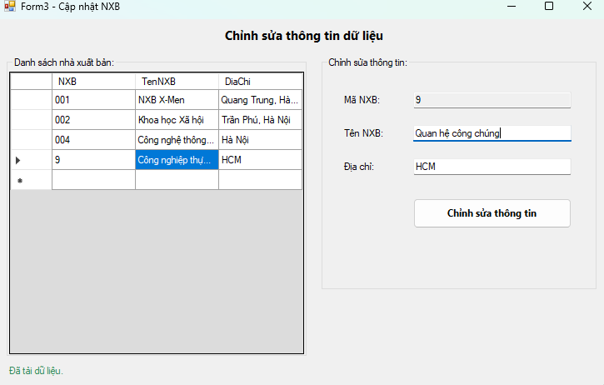
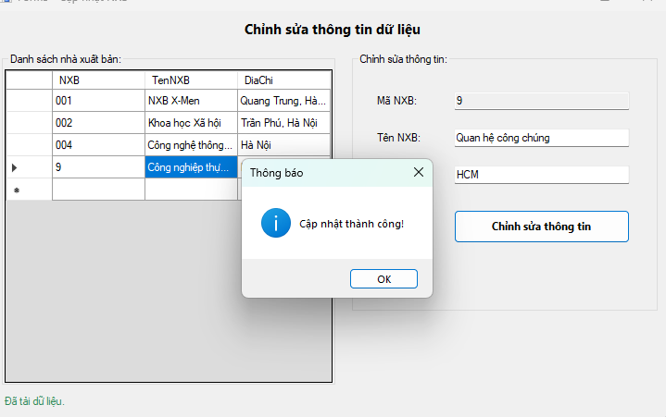

Form3.cs
using System;
using System.Data;
using System.Data.SqlClient;
using System.Windows.Forms;

namespace _1150080131_TranDuc_Lab7
{
public partial class Form3 : Form
{
private const string CONN_STR =
@"Data Source=LAPTOP-LQGGA8E3\MSSQLSERVER2;Initial Catalog=QLSV;Integrated Security=True;Persist Security Info=False;Encrypt=True;TrustServerCertificate=True";

private const string TABLE = "NhaXuatBan";
private const string COL_MA = "NXB";
private const string COL_TEN = "TenNXB";
private const string COL_DC = "DiaChi";

public Form3()
{
InitializeComponent();
}

private void Form3_Load(object sender, EventArgs e)
{
LoadGrid();
SetEditing(false);
}

private void LoadGrid()
{
try
{
using (var con = new SqlConnection(CONN_STR))
using (var da = new SqlDataAdapter($"SELECT * FROM [{TABLE}] ORDER BY [{COL_MA}]", con))
{
var dt = new DataTable();
da.Fill(dt);
dgvDanhSach.DataSource = dt;
}
lblStatus.Text = "Đã tải dữ liệu.";
}
catch (Exception ex)
{
MessageBox.Show(ex.Message, "Lỗi tải dữ liệu", MessageBoxButtons.OK, MessageBoxIcon.Error);
}
}

private void dgvDanhSach_CellClick(object sender, DataGridViewCellEventArgs e)
{
if (e.RowIndex < 0) return;
var row = dgvDanhSach.Rows[e.RowIndex];
txtMaNXB.Text = Convert.ToString(row.Cells[COL_MA].Value);
txtTenNXB.Text = Convert.ToString(row.Cells[COL_TEN].Value);
txtDiaChi.Text = Convert.ToString(row.Cells[COL_DC].Value);
SetEditing(true);
}

private void SetEditing(bool enabled)
{
// Ma NXB không cho sửa (khóa chính)
txtMaNXB.ReadOnly = true;
btnCapNhat.Enabled = enabled;
}

private bool ValidateInput(out string msg)
{
if (string.IsNullOrWhiteSpace(txtMaNXB.Text))
{
msg = "Chưa chọn bản ghi cần sửa.";
return false;
}
if (string.IsNullOrWhiteSpace(txtTenNXB.Text))
{
msg = "Vui lòng nhập Tên NXB.";
return false;
}
msg = "";
return true;
}

private void btnCapNhat_Click(object sender, EventArgs e)
{
try
{
if (!ValidateInput(out string msg))
{
MessageBox.Show(msg, "Thiếu dữ liệu", MessageBoxButtons.OK, MessageBoxIcon.Warning);
return;
}

using (var con = new SqlConnection(CONN_STR))
using (var cmd = new SqlCommand($@"
UPDATE [{TABLE}]
SET [{COL_TEN}] = @Ten, [{COL_DC}] = @DC
WHERE [{COL_MA}] = @Ma", con))
{
cmd.Parameters.AddWithValue("@Ten", txtTenNXB.Text.Trim());
cmd.Parameters.AddWithValue("@DC", txtDiaChi.Text.Trim());
cmd.Parameters.AddWithValue("@Ma", txtMaNXB.Text.Trim());

con.Open();
int kq = cmd.ExecuteNonQuery();
if (kq > 0)
{
MessageBox.Show("Cập nhật thành công!", "Thông báo",
MessageBoxButtons.OK, MessageBoxIcon.Information);
LoadGrid();
// Giữ lại dữ liệu đã sửa để người dùng thấy
lblStatus.Text = $"Đã cập nhật: {txtMaNXB.Text}";
}
else
{
MessageBox.Show("Không có dòng nào được cập nhật!", "Thông báo",
MessageBoxButtons.OK, MessageBoxIcon.Warning);
}
}
}
catch (Exception ex)
{
MessageBox.Show(ex.Message, "Lỗi cập nhật", MessageBoxButtons.OK, MessageBoxIcon.Error);
}
}
}
}

Form3.Designer.cs
namespace _1150080131_TranDuc_Lab7
{
partial class Form3
{
private System.ComponentModel.IContainer components = null;
private System.Windows.Forms.GroupBox groupLeft;
private System.Windows.Forms.GroupBox groupRight;
private System.Windows.Forms.DataGridView dgvDanhSach;
private System.Windows.Forms.TextBox txtMaNXB;
private System.Windows.Forms.TextBox txtTenNXB;
private System.Windows.Forms.TextBox txtDiaChi;
private System.Windows.Forms.Label lblMa;
private System.Windows.Forms.Label lblTen;
private System.Windows.Forms.Label lblDiaChi;
private System.Windows.Forms.Button btnCapNhat;
private System.Windows.Forms.Label lblTitle;
private System.Windows.Forms.Label lblStatus;

protected override void Dispose(bool disposing)
{
if (disposing && (components != null)) components.Dispose();
base.Dispose(disposing);
}

private void InitializeComponent()
{
this.groupLeft = new System.Windows.Forms.GroupBox();
this.dgvDanhSach = new System.Windows.Forms.DataGridView();
this.groupRight = new System.Windows.Forms.GroupBox();
this.lblMa = new System.Windows.Forms.Label();
this.lblTen = new System.Windows.Forms.Label();
this.lblDiaChi = new System.Windows.Forms.Label();
this.txtMaNXB = new System.Windows.Forms.TextBox();
this.txtTenNXB = new System.Windows.Forms.TextBox();
this.txtDiaChi = new System.Windows.Forms.TextBox();
this.btnCapNhat = new System.Windows.Forms.Button();
this.lblTitle = new System.Windows.Forms.Label();
this.lblStatus = new System.Windows.Forms.Label();
this.groupLeft.SuspendLayout();
((System.ComponentModel.ISupportInitialize)(this.dgvDanhSach)).BeginInit();
this.groupRight.SuspendLayout();
this.SuspendLayout();
//
// lblTitle
//
this.lblTitle.Anchor = System.Windows.Forms.AnchorStyles.Top;
this.lblTitle.AutoSize = true;
this.lblTitle.Font = new System.Drawing.Font("Segoe UI", 11F, System.Drawing.FontStyle.Bold);
this.lblTitle.Location = new System.Drawing.Point(270, 9);
this.lblTitle.Name = "lblTitle";
this.lblTitle.Size = new System.Drawing.Size(202, 25);
this.lblTitle.Text = "Chỉnh sửa thông tin dữ liệu";
//
// groupLeft
//
this.groupLeft.Controls.Add(this.dgvDanhSach);
this.groupLeft.Location = new System.Drawing.Point(12, 45);
this.groupLeft.Name = "groupLeft";
this.groupLeft.Size = new System.Drawing.Size(360, 360);
this.groupLeft.TabStop = false;
this.groupLeft.Text = "Danh sách nhà xuất bản:";
//
// dgvDanhSach
//
this.dgvDanhSach.BackgroundColor = System.Drawing.Color.Gainsboro;
this.dgvDanhSach.BorderStyle = System.Windows.Forms.BorderStyle.FixedSingle;
this.dgvDanhSach.ColumnHeadersHeightSizeMode = System.Windows.Forms.DataGridViewColumnHeadersHeightSizeMode.AutoSize;
this.dgvDanhSach.Dock = System.Windows.Forms.DockStyle.Fill;
this.dgvDanhSach.Location = new System.Drawing.Point(3, 18);
this.dgvDanhSach.Name = "dgvDanhSach";
this.dgvDanhSach.RowHeadersWidth = 51;
this.dgvDanhSach.RowTemplate.Height = 24;
this.dgvDanhSach.Size = new System.Drawing.Size(354, 339);
this.dgvDanhSach.TabIndex = 0;
this.dgvDanhSach.CellClick += new System.Windows.Forms.DataGridViewCellEventHandler(this.dgvDanhSach_CellClick);
//
// groupRight
//
this.groupRight.Controls.Add(this.btnCapNhat);
this.groupRight.Controls.Add(this.txtDiaChi);
this.groupRight.Controls.Add(this.txtTenNXB);
this.groupRight.Controls.Add(this.txtMaNXB);
this.groupRight.Controls.Add(this.lblDiaChi);
this.groupRight.Controls.Add(this.lblTen);
this.groupRight.Controls.Add(this.lblMa);
this.groupRight.Location = new System.Drawing.Point(390, 45);
this.groupRight.Name = "groupRight";
this.groupRight.Size = new System.Drawing.Size(330, 280);
this.groupRight.TabStop = false;
this.groupRight.Text = "Chỉnh sửa thông tin:";
//
// Labels & Textboxes
//
this.lblMa.AutoSize = true;
this.lblMa.Location = new System.Drawing.Point(24, 45);
this.lblMa.Text = "Mã NXB:";
this.txtMaNXB.Location = new System.Drawing.Point(110, 42);
this.txtMaNXB.ReadOnly = true;
this.txtMaNXB.Size = new System.Drawing.Size(190, 22);

this.lblTen.AutoSize = true;
this.lblTen.Location = new System.Drawing.Point(24, 85);
this.lblTen.Text = "Tên NXB:";
this.txtTenNXB.Location = new System.Drawing.Point(110, 82);
this.txtTenNXB.Size = new System.Drawing.Size(190, 22);

this.lblDiaChi.AutoSize = true;
this.lblDiaChi.Location = new System.Drawing.Point(24, 125);
this.lblDiaChi.Text = "Địa chỉ:";
this.txtDiaChi.Location = new System.Drawing.Point(110, 122);
this.txtDiaChi.Size = new System.Drawing.Size(190, 22);

//
// btnCapNhat
//
this.btnCapNhat.Font = new System.Drawing.Font("Segoe UI", 9F, System.Drawing.FontStyle.Bold);
this.btnCapNhat.Location = new System.Drawing.Point(110, 170);
this.btnCapNhat.Name = "btnCapNhat";
this.btnCapNhat.Size = new System.Drawing.Size(190, 36);
this.btnCapNhat.Text = "Chỉnh sửa thông tin";
this.btnCapNhat.UseVisualStyleBackColor = true;
this.btnCapNhat.Click += new System.EventHandler(this.btnCapNhat_Click);
//
// lblStatus
//
this.lblStatus.AutoSize = true;
this.lblStatus.ForeColor = System.Drawing.Color.SeaGreen;
this.lblStatus.Location = new System.Drawing.Point(12, 415);
this.lblStatus.Size = new System.Drawing.Size(0, 16);
//
// Form3
//
this.AutoScaleDimensions = new System.Drawing.SizeF(8F, 16F);
this.ClientSize = new System.Drawing.Size(732, 440);
this.Controls.Add(this.lblStatus);
this.Controls.Add(this.lblTitle);
this.Controls.Add(this.groupRight);
this.Controls.Add(this.groupLeft);
this.MinimumSize = new System.Drawing.Size(700, 430);
this.Name = "Form3";
this.StartPosition = System.Windows.Forms.FormStartPosition.CenterScreen;
this.Text = "Form3 - Cập nhật NXB";
this.Load += new System.EventHandler(this.Form3_Load);
this.groupLeft.ResumeLayout(false);
((System.ComponentModel.ISupportInitialize)(this.dgvDanhSach)).EndInit();
this.groupRight.ResumeLayout(false);
this.groupRight.PerformLayout();
this.ResumeLayout(false);
this.PerformLayout();
}
}
}

Thực hành 4: Xóa dữ liệu cho bảng Nhà xuất bản
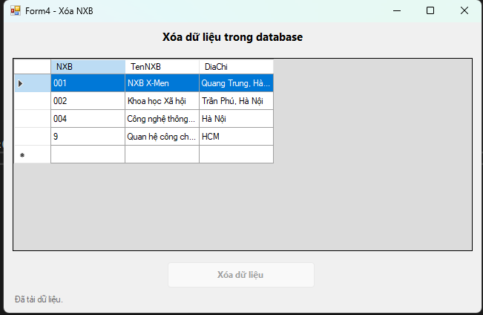
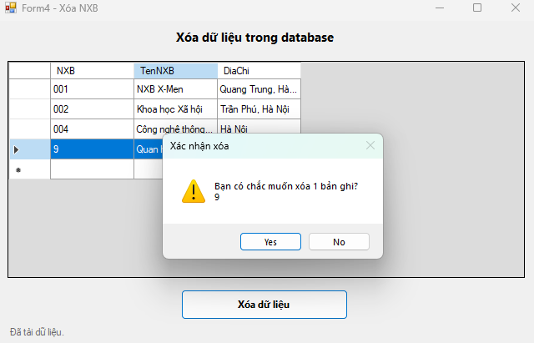

Form4.cs
using System;
using System.Data;
using System.Data.SqlClient;
using System.Linq;
using System.Windows.Forms;

namespace _1150080131_TranDuc_Lab7
{
public partial class Form4 : Form
{
// ====== Kết nối: đổi 1 dòng này nếu bạn dùng QLSV ======
private const string CONN_STR =
@"Data Source=LAPTOP-LQGGA8E3\MSSQLSERVER2;Initial Catalog=QLSV;Integrated Security=True;Persist Security Info=False;Encrypt=True;TrustServerCertificate=True";

private const string TABLE = "NhaXuatBan";
private const string COL_MA = "NXB";
private const string COL_TEN = "TenNXB";
private const string COL_DC = "DiaChi";

public Form4()
{
InitializeComponent();
}

private void Form4_Load(object sender, EventArgs e)
{
LoadGrid();
btnXoa.Enabled = false;
}

private void LoadGrid()
{
try
{
using (var con = new SqlConnection(CONN_STR))
using (var da = new SqlDataAdapter($"SELECT * FROM [{TABLE}] ORDER BY [{COL_MA}]", con))
{
var dt = new DataTable();
da.Fill(dt);
dgvDanhSach.DataSource = dt;
}
lblStatus.Text = "Đã tải dữ liệu.";
}
catch (Exception ex)
{
MessageBox.Show(ex.Message, "Lỗi tải dữ liệu", MessageBoxButtons.OK, MessageBoxIcon.Error);
}
}

private void dgvDanhSach_SelectionChanged(object sender, EventArgs e)
{
btnXoa.Enabled = dgvDanhSach.SelectedRows.Count > 0;
}

private void btnXoa_Click(object sender, EventArgs e)
{
var rows = dgvDanhSach.SelectedRows.Cast<DataGridViewRow>().ToList();
if (rows.Count == 0) return;

var ids = rows.Select(r => Convert.ToString(r.Cells[COL_MA].Value)).Where(s => !string.IsNullOrWhiteSpace(s)).ToList();
if (ids.Count == 0) return;

var confirm = MessageBox.Show(
$"Bạn có chắc muốn xóa {ids.Count} bản ghi?\n" +
$"{string.Join(", ", ids.Take(5))}{(ids.Count > 5 ? "..." : "")}",
"Xác nhận xóa", MessageBoxButtons.YesNo, MessageBoxIcon.Warning);

if (confirm != DialogResult.Yes) return;

try
{
using (var con = new SqlConnection(CONN_STR))
{
con.Open();
using (var tx = con.BeginTransaction())
using (var cmd = new SqlCommand($"DELETE FROM [{TABLE}] WHERE [{COL_MA}] = @id", con, tx))
{
cmd.Parameters.Add("@id", SqlDbType.NVarChar, 50);
int affectedTotal = 0;

foreach (var id in ids)
{
cmd.Parameters["@id"].Value = id;
affectedTotal += cmd.ExecuteNonQuery();
}

tx.Commit();
MessageBox.Show($"Đã xóa {affectedTotal} dòng.", "Thành công",
MessageBoxButtons.OK, MessageBoxIcon.Information);
}
}

LoadGrid();
btnXoa.Enabled = false;
}
catch (SqlException sx)
{
// Trường hợp dính FK
MessageBox.Show(
"Không thể xóa do ràng buộc khóa ngoại hoặc lỗi CSDL.\n\n" + sx.Message,
"Lỗi khi xóa", MessageBoxButtons.OK, MessageBoxIcon.Error);
}
catch (Exception ex)
{
MessageBox.Show(ex.Message, "Lỗi khi xóa", MessageBoxButtons.OK, MessageBoxIcon.Error);
}
}
}
}

Form4.Desginer.cs
namespace _1150080131_TranDuc_Lab7
{
partial class Form4
{
private System.ComponentModel.IContainer components = null;
private System.Windows.Forms.Label lblTitle;
private System.Windows.Forms.DataGridView dgvDanhSach;
private System.Windows.Forms.Button btnXoa;
private System.Windows.Forms.Label lblStatus;

protected override void Dispose(bool disposing)
{
if (disposing && (components != null)) components.Dispose();
base.Dispose(disposing);
}

private void InitializeComponent()
{
this.lblTitle = new System.Windows.Forms.Label();
this.dgvDanhSach = new System.Windows.Forms.DataGridView();
this.btnXoa = new System.Windows.Forms.Button();
this.lblStatus = new System.Windows.Forms.Label();
((System.ComponentModel.ISupportInitialize)(this.dgvDanhSach)).BeginInit();
this.SuspendLayout();
//
// lblTitle
//
this.lblTitle.Anchor = System.Windows.Forms.AnchorStyles.Top;
this.lblTitle.AutoSize = true;
this.lblTitle.Font = new System.Drawing.Font("Segoe UI", 11F, System.Drawing.FontStyle.Bold);
this.lblTitle.Location = new System.Drawing.Point(210, 9);
this.lblTitle.Name = "lblTitle";
this.lblTitle.Size = new System.Drawing.Size(224, 25);
this.lblTitle.Text = "Xóa dữ liệu trong database";
//
// dgvDanhSach
//
this.dgvDanhSach.Anchor = ((System.Windows.Forms.AnchorStyles)((((System.Windows.Forms.AnchorStyles.Top | System.Windows.Forms.AnchorStyles.Bottom)
| System.Windows.Forms.AnchorStyles.Left)
| System.Windows.Forms.AnchorStyles.Right)));
this.dgvDanhSach.BackgroundColor = System.Drawing.Color.Gainsboro;
this.dgvDanhSach.BorderStyle = System.Windows.Forms.BorderStyle.FixedSingle;
this.dgvDanhSach.ColumnHeadersHeightSizeMode = System.Windows.Forms.DataGridViewColumnHeadersHeightSizeMode.AutoSize;
this.dgvDanhSach.Location = new System.Drawing.Point(12, 48);
this.dgvDanhSach.MultiSelect = true;
this.dgvDanhSach.Name = "dgvDanhSach";
this.dgvDanhSach.RowHeadersWidth = 51;
this.dgvDanhSach.RowTemplate.Height = 24;
this.dgvDanhSach.SelectionMode = System.Windows.Forms.DataGridViewSelectionMode.FullRowSelect;
this.dgvDanhSach.Size = new System.Drawing.Size(620, 260);
this.dgvDanhSach.TabIndex = 0;
this.dgvDanhSach.SelectionChanged += new System.EventHandler(this.dgvDanhSach_SelectionChanged);
//
// btnXoa
//
this.btnXoa.Anchor = System.Windows.Forms.AnchorStyles.Bottom;
this.btnXoa.Enabled = false;
this.btnXoa.Font = new System.Drawing.Font("Segoe UI", 9F, System.Drawing.FontStyle.Bold);
this.btnXoa.Location = new System.Drawing.Point(220, 322);
this.btnXoa.Name = "btnXoa";
this.btnXoa.Size = new System.Drawing.Size(200, 36);
this.btnXoa.TabIndex = 1;
this.btnXoa.Text = "Xóa dữ liệu";
this.btnXoa.UseVisualStyleBackColor = true;
this.btnXoa.Click += new System.EventHandler(this.btnXoa_Click);
//
// lblStatus
//
this.lblStatus.Anchor = ((System.Windows.Forms.AnchorStyles)((System.Windows.Forms.AnchorStyles.Bottom | System.Windows.Forms.AnchorStyles.Left)));
this.lblStatus.AutoSize = true;
this.lblStatus.ForeColor = System.Drawing.Color.DimGray;
this.lblStatus.Location = new System.Drawing.Point(12, 366);
this.lblStatus.Name = "lblStatus";
this.lblStatus.Size = new System.Drawing.Size(0, 16);
//
// Form4
//
this.AutoScaleDimensions = new System.Drawing.SizeF(8F, 16F);
this.ClientSize = new System.Drawing.Size(644, 391);
this.Controls.Add(this.lblStatus);
this.Controls.Add(this.btnXoa);
this.Controls.Add(this.dgvDanhSach);
this.Controls.Add(this.lblTitle);
this.MinimumSize = new System.Drawing.Size(660, 430);
this.Name = "Form4";
this.StartPosition = System.Windows.Forms.FormStartPosition.CenterScreen;
this.Text = "Form4 - Xóa NXB";
this.Load += new System.EventHandler(this.Form4_Load);
((System.ComponentModel.ISupportInitialize)(this.dgvDanhSach)).EndInit();
this.ResumeLayout(false);
this.PerformLayout();
}
}
}

